Assessment Schedule – 2012

Music: Demonstrate knowledge of conventions in a range of music scores (91276)

Evidence Statement
Question | Achievement | Achievement with Merit | Achievement with Excellence
ONE | Score Extract A: Cavatina
(a) (i) | Identifies ONE Italian term:  - Slowly: Lento / Adagio (accept Largo / Grave)  - Smoothly: Legato
(ii) | Identifies the instrument AND the instruction it would be unable to follow:  - Instrument: Double bass  - Instruction: Smoothly / legato | Explains ONE reason why the double bass would be unable to follow the instruction to play smoothly / legato, eg:  - because the notes are plucked (or pizz), the sound dies away, causing a break between the notes  - because there are rests between the notes.
(iii) | Identifies TWO of:  ① Phrase mark  ② Slur  ③ Tie. | Explains the meaning of TWO, eg:  ① Play all the notes as a single idea  ② Play the notes smoothly / together (without tonguing)  ③ Play / sustain the notes (for the full duration of both / all) without a break  Other responses possible.
(iv) |  | Identifies the tempo modifications and describes ONE similarity and ONE difference between them:  - Similarity: “rit.” means slow down (at once)  - Difference: ‘poco’ means ‘a little’, ‘molto’ means ‘a lot’
(v) |  |  | Identifies the sections of the score AND explains the order in which they are played, exactly as shown:
  First bar | Last bar | Musical instruction
  1 | 51 | D.C. al Ø
  1 | 24 | To CODA
  52 | 63 | CODA

Question One cont’d
Question | Achievement | Achievement with Merit | Achievement with Excellence
(b) (i) | Identifies the quantity of THREE intervals. | Identifies the quality AND quantity of THREE intervals.
- Perfect 4th
- Major 13th / compound major 6th
- Minor 13th / compound minor 6th
- (Perfect) octave (or 8th)
(ii) |  | Transcribes the double bass part into the L.H. piano part, with:  - FOUR (of 5) pitches correct  - key signature  - all rests  - note / rest alignment correct  - all stem directions correct.
(iii) |  | Identifies the transcription error, ie the notes are written an octave higher (than the guitar sounds) / should have been written an octave lower (to match the pitch of the guitar).
(iv) |  |  | Transcribes the flute part for alto saxophone, with:  - key signature correct  - ALL pitches correct  - note / rest alignment correct  - all stem directions correct.
 | 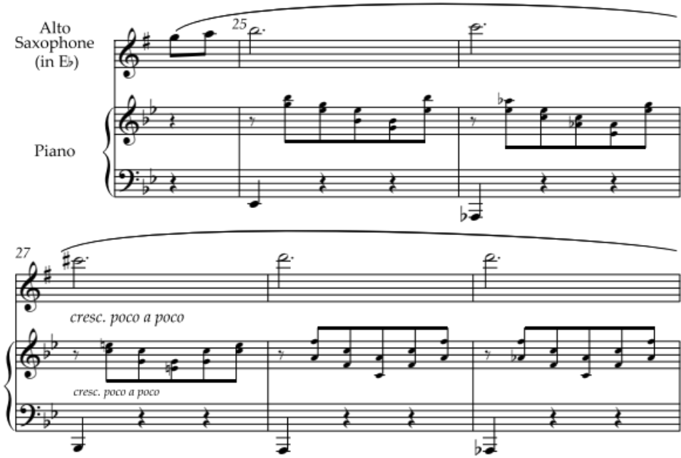

N1 | N2 | A3 | A4 | M5 | M6 | E7 | E8
ONE partial piece of evidence at Achievement level. | TWO pieces of evidence at Achievement level. | TWO pieces of evidence at Achievement level. | THREE pieces of evidence at Achievement level. | TWO pieces of evidence at Merit level. | THREE pieces of evidence at Merit level. | ONE piece of evidence at Excellence level. | TWO pieces of evidence at Excellence level.
N0= No response; no relevant evidence.

Question | Achievement | Achievement with Merit | Achievement with Excellence
TWO | Score Extract B: “Five Eyes”
(a) (i) | Identifies the key of ONE passage: | Gives ONE piece of evidence to justify the identification of ONE key, eg:
 | - A – D minor | - Raised / sharpened leading note, C♯, in bar 10  - Perfect cadence implied over bars 10–11 (bass has dominant–tonic)
 | - B – D major | - Raised third, F♯, throughout passage  - Pedal D (tonic pedal) in bass  - D major is the tonic major of the home key, D minor
(ii) | Identifies the Roman numerals for a perfect cadence, and correctly notates:  - bass notes (A, D)  - durations (‰ | Œ). | Identifies the Roman numerals for a perfect cadence, and notates a perfect cadence in D minor with correct bass notes and durations, and in the upper parts no more than two of the following incorrect:  - raised leading note (C♯)  - leading note not doubled  - stepwise movement from leading note to tonic  - no notes omitted from either chord  - smooth voice-leading (ie not just block chords). | Identifies the Roman numerals for a perfect cadence, and notates a perfect cadence in D minor, with no errors.
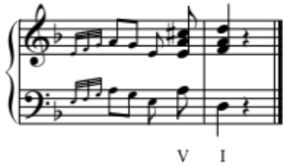
Other voicings possible.
(b) (i) | Identifies THREE (of four) compositional devices.  - First instance of melisma:  old (bar 5)  - Imitation (ONE of):  Squeaking and scamp’ring” (19–20)  “Then down they pounce” (21–23)  - Three bars of contrary motion:  “In Hans’ old mill his three black cats Watch the bins for the” (4–6 OR 5–7)  - Three bars in thirds:  “Squeaks from the flour sacks, squeaks from where The cold wind stirs on the” (15–17)
Question Two cont’d
Question | Achievement | Achievement with Merit | Achievement with Excellence
(b) (ii) | Identifies ONE instance of EACH compositional device, eg:  - With anacrusis:  “In” (bar 4)  “Their” (bar 10)  “The” (bar 16)  “Then” (bar 21 / 22)  “At” (bar 23)  “While” (bar 25)  - Without anacrusis:  “Watch” (bar 7)  “Whisker” (bar 9)  “Squeaks” (bar 15)  “Squeaking” (bar 19 / 20) | Explains why the anacrusis is used, eg:  - So the accented word or syllable is on a strong / down / first beat of the bar
(iii) |  |  | Identifies and explains the use of TWO compositional devices for EACH lyrical phrase, eg:  - “Then down they pounce …”  Imitation in vocal parts (bars 21–23) suggests the cats pouncing one after another  Upper accompaniment figure (inverted in bars 23 and 25) suggests the cats’ long tails moving  Move to tonic major key (D major) suggests playfulness / a lighter mood  - “Then up he climbs …”  Chromatic ascending of melodic line describes climbing  Lack of key centre suggests instability, as of the “creaking mill”  Imitation between voice parts suggests the cats emerging at different times  Other responses possible.

N1 | N2 | A3 | A4 | M5 | M6 | E7 | E8
ONE partial piece of evidence at Achievement level. | ONE piece of evidence at Achievement level. | TWO pieces of evidence at Achievement level. | THREE pieces of evidence at Achievement level. | ONE piece of evidence at Merit level. | TWO pieces of evidence at Merit level. | ONE piece of evidence at Excellence level. | TWO pieces of evidence at Excellence level.
N0= No response; no relevant evidence.

Question | Achievement | Achievement with Merit | Achievement with Excellence
THREE | Score Extract C: “Poi E”
(a) (i) | Identifies and describes TWO string techniques used in bars 1–10:  - arco: the strings are played with the bow  - double-stopping: notes on two strings are played simultaneously  - pizzicato: the strings are plucked.
(ii) | Identifies TWO instruments:  - [A] – Clarinet  - [B] – Horn  - [C] – Trumpet  - [D] – Double bass | Explains that these instruments are all transposing instruments / their sounding pitch is different from the written pitch.
(iii) |  |  | Describes TWO ways that pairs of instruments are directed to play in unison, AND specifies one pair of EACH instruments so directed.  - “a 2” (ONE of):  flutes – bars 6, 15  oboes – bar 15  clarinets (accept “[A]”) – bar 19  bassoons – bars 5, 15  horns (accept “[B]”) – bar 15  trumpets (accept “[C]”) –bar 15  trombones – bar 15  - notes with stems up and down (ONE of):  horns (accept “[B]”) – bar 1  clarinets (accept “[A]”) – bar 5
(b) (i) | Identifies THREE chords using EITHER Roman numeral OR jazz / rock notation. | Identifies THREE chords using BOTH Roman numeral AND jazz / rock notation. | Names the scale degree of the root of all FOUR chords.
 | Roman numeral | Jazz / rock | Scale degree
(1) | iib | Bm/D | Supertonic
(2) | I¸4 | A¸4 | Tonic
(3) | V | E | Dominant
(4) | V7 | E7 | Dominant

Question Three cont’d
Question | Achievement | Achievement with Merit | Achievement with Excellence
(b) (ii) | Prepares the score by including on every stave:  - the instrument names (accept [B] and [C] for Horns and Trumpets)  - the key signature of D major  - the time signature of c | Partially transcribes the score by including:  - the tempo marking  - dynamic markings  - correct stem directions  - rests in empty bars. | Accurately transcribes FOUR (of 6) brass parts to open score.
 | 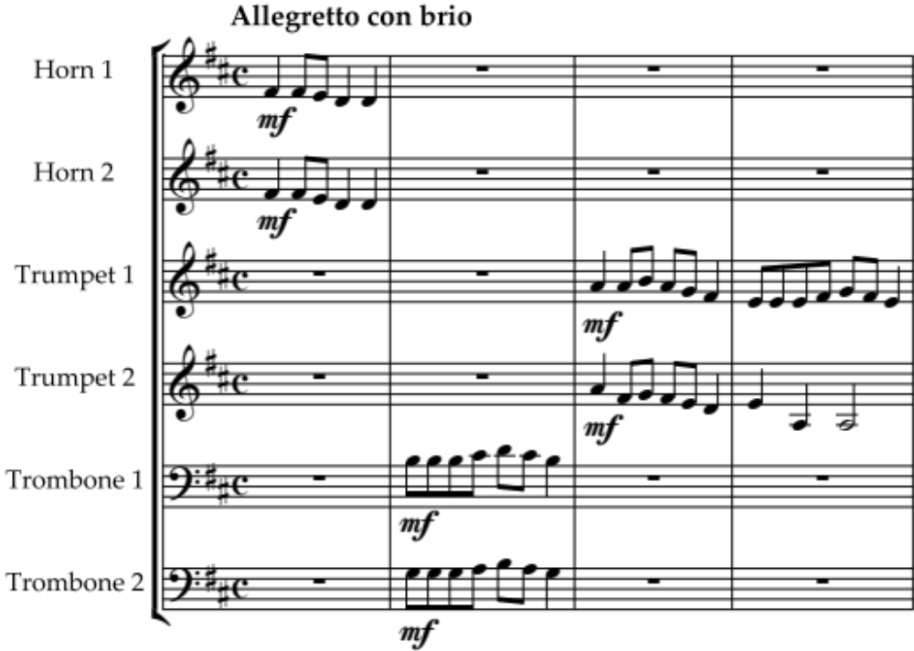

N1 | N2 | A3 | A4 | M5 | M6 | E7 | E8
ONE partial piece of evidence at Achievement level. | ONE piece of evidence at Achievement level. | TWO pieces of evidence at Achievement level. | THREE pieces of evidence at Achievement level. | TWO pieces of evidence at Merit level. | THREE pieces of evidence at Merit level. | TWO pieces of evidence at Excellence level. | THREE pieces of evidence at Excellence level.
N0= No response; no relevant evidence.

Judgement Statement
 | Not Achieved | Achievement | Achievement  with Merit | Achievement  with Excellence
Score range | 0 – 8 | 9 – 13 | 14 – 19 | 20 – 24

